TimeTable Application
Design Documentation
Programming Assignment #1 TimeTable | 2023031812 | 김마린

1. Program Architecture Design
The Program consists of three classes which name are Subject, TimeTable, TimeTableApp.

1.1 Class Overview
Class Name | Role | Key Methods and Instance Variables
Subject | Collection of components which consist of each Subject. | Stores name, tutor, room of one subject. Constructors, getters, setters, equals(), toString(), getDetails()
TimeTable | Initialize TimeTable and get subject on specific time. And add a subject in specific time. | Owns the 10×5 Subject array.  Handles get/set schedule and formatted print.
TimeTableApp | Interface | Contains main(). Reads keyboard input via Scanner. Drives the do-while loop based on input numbers

1.2 Class Relationship Diagram
┌─────────────────────┐
[TimeTableApp] main(), Scanner, menu loop
└──────────┬──────────┘
┌──────────▼──────────┐
[TimeTable] DAYS enum, Subject[10][5]
└──────────┬──────────┘
┌──────────▼──────────┐
[Subject] name, tutor, room
└─────────────────────┘

1.3 Core Data Structure
The timetable is stored as a two-dimensional array: Subject[10][5]

Period / Day | MONDAY | TUESDAY | WEDNESDAY | THURSDAY | FRIDAY
Period 1 [row 0] | ---- | ---- | ---- | ---- | ----
Period 2 [row 1] | ---- | ---- | ---- | ---- | ----
Period 3 [row 2] | ---- | ---- | ---- | ---- | ----
Period 4 [row 3] | BREAK | BREAK | BREAK | BREAK | BREAK
Period 5 [row 4] | ---- | ---- | ---- | ---- | ----
Period 6 [row 5] | ---- | ---- | ---- | ---- | ----
Period 7 [row 6] | ---- | ---- | ---- | ---- | ----
Period 8 [row 7] | LUNCH | LUNCH | LUNCH | LUNCH | LUNCH
Period 9 [row 8] | ---- | ---- | ---- | ---- | ----
Period 10 [row 9] | ---- | ---- | ---- | ---- | ----

2. Implementation Methodology

2.1 Subject — Data Encapsulation

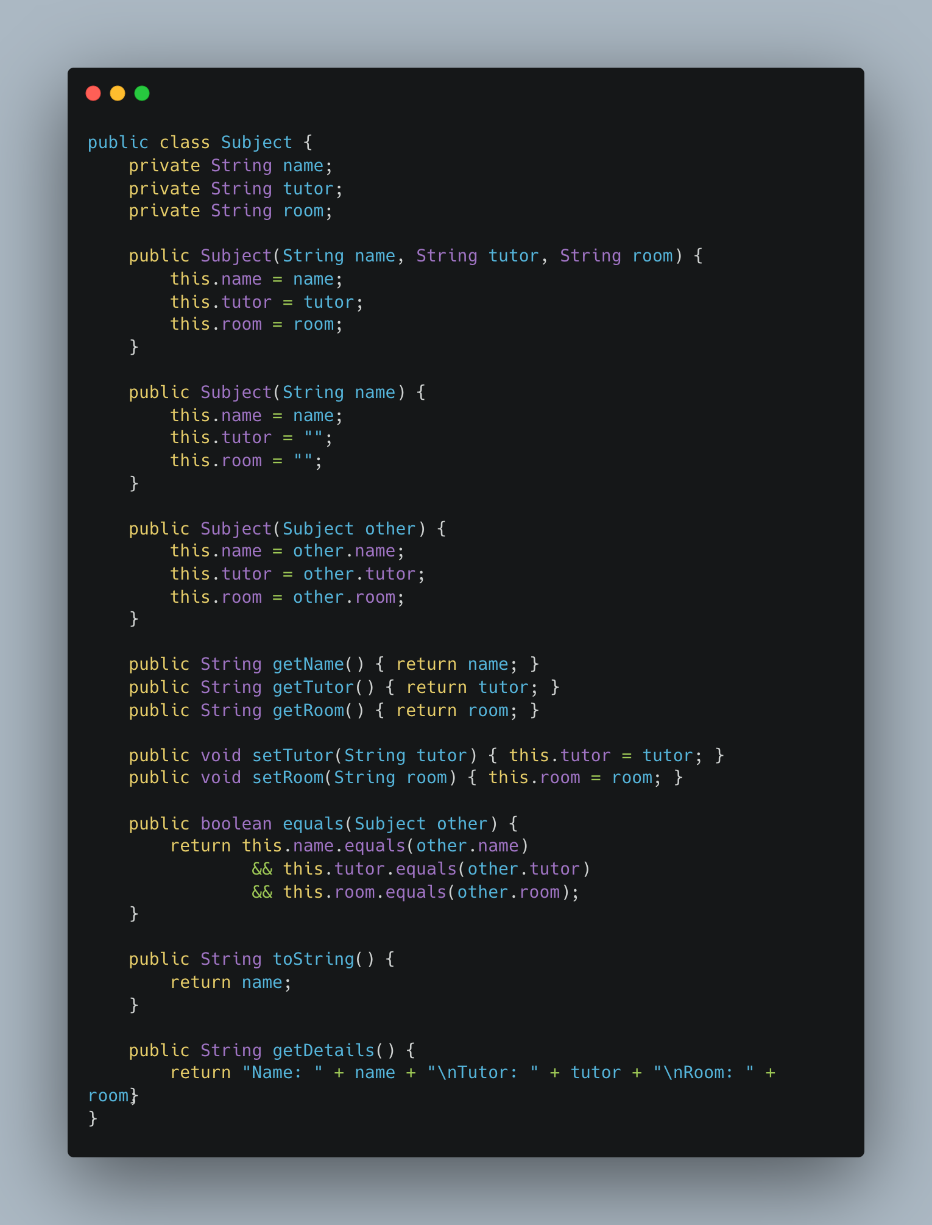
Declaring Three instance Variables:
All three fields (name, tutor, room) are declared private. These String type instance variables cannot be accessed directly by name from outside the class. This is representation of information hiding or Encapsulation.

Three constructors:
- Subject(String name, String tutor, String room) — Creates Subject type object when new operator’s argument contains name, tutor and room.
- Subject(String name) — Creates Subject type object when new operator’s argument contains only name. Initializing name, tutor=””, room=””
- Subject(Subject other) — Copy Constructor for Subject Class. Since name, tutor, and room’s data type are all String data type which is immutable, we don’t need to consider data leak when the copy constructor is called.

Accessor and Mutators:
Getter returns name, tutor and room.
Setter initializes name, tutor and room.

equlas() Method:
Compares two Subject type object’s instance variables. If and only if two object’s instance variables are same each, then the method’s return value is true;

toString() Method:
returns name.

getDetails() Method:
returns name, tutor and room in formatted way.

2.2 TimeTable — Array Management & Business Rules

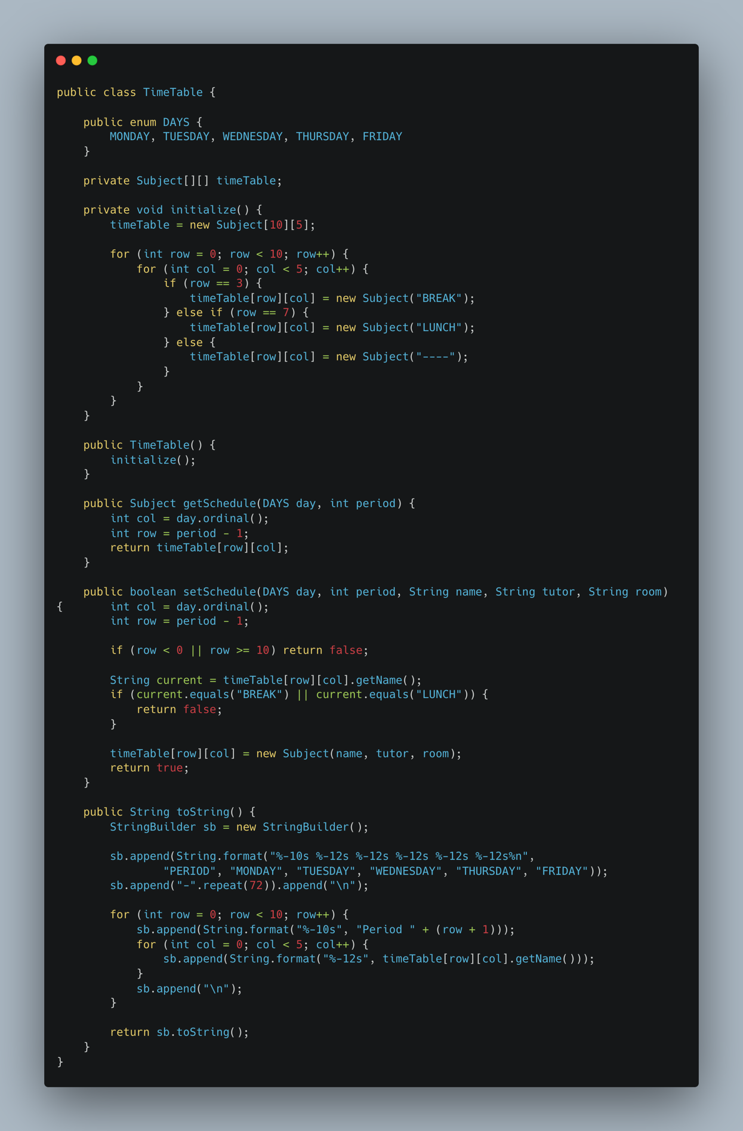
Index mapping logic:
Setting Days(Monday to Friday)

Initialize() method:
Initialize Subject type [10][5] two dimension array. Row #3 must be initialized to BREAK and Row #7 should be initialized to LUNCH. And this method should be declared to private because it should be called once from the constructor.

getSchedule() method:
returns exact indexed variable based on below.
- (period – 1) converts user input (1–10) to array row (0–9)
- day.ordinal() converts the DAYS enum to its column index (MONDAY=0, FRIDAY=4)

setSchedule() method:
- Returns false if the row is out of range(row < 0 or row > 0 or BREAK or LUNCH)
- Create indexed variable if the row in range.

setSchedule() method:
return the whole Schedule in formatted way.

2.3 TimeTableApp — User Interface & Input Handling

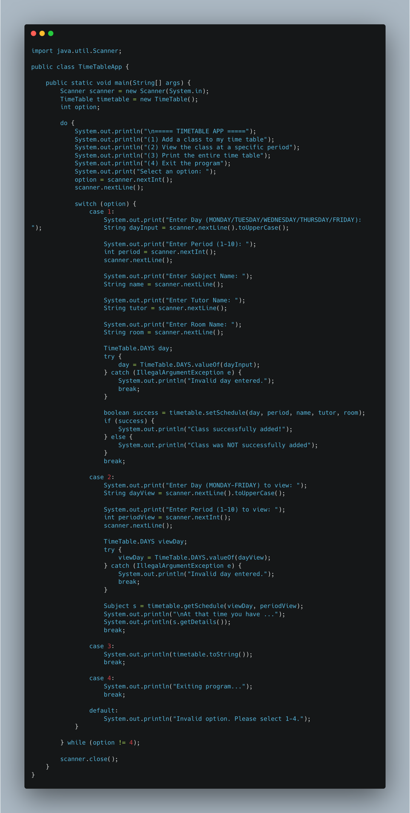
Using do-while loop, the menu is displayed everytime.
Using switch grammar to check which menu to be executed.
Scanner buffer management:
- nextInt() reads only the number, leaving a newline character(\n) in the buffer
- scanner.nextLine() is called immediately after each nextInt() to delete the newline character.

Day input should be converted to uppercase before passing to valueOf(). So the user can insert both upper case and lower case.

Try-catch checks the day is inputted correctly.

The result of setSchedule() (true/false) is used which line should be outputted.

3. Output Examples
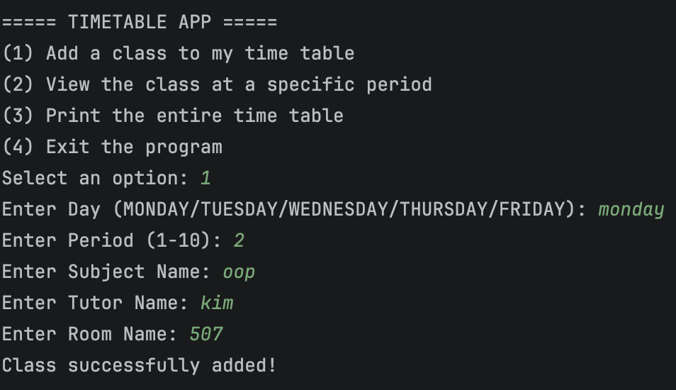
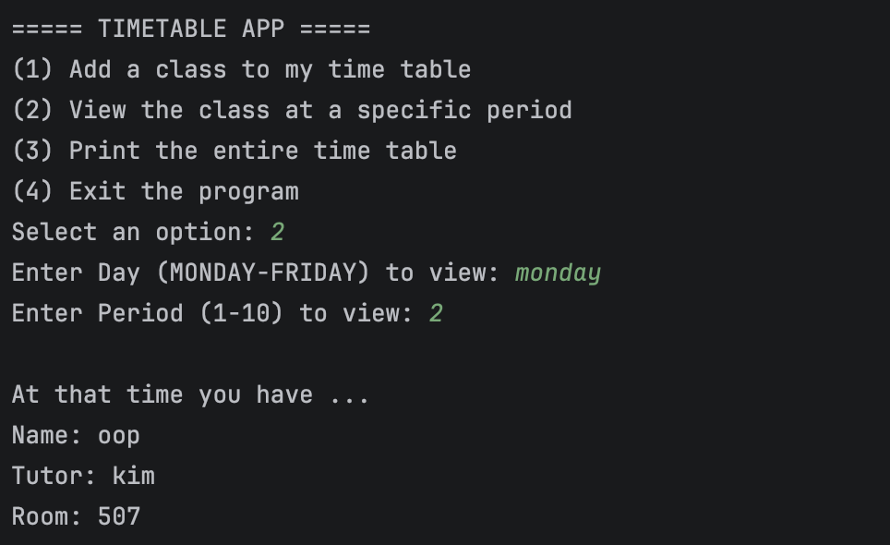
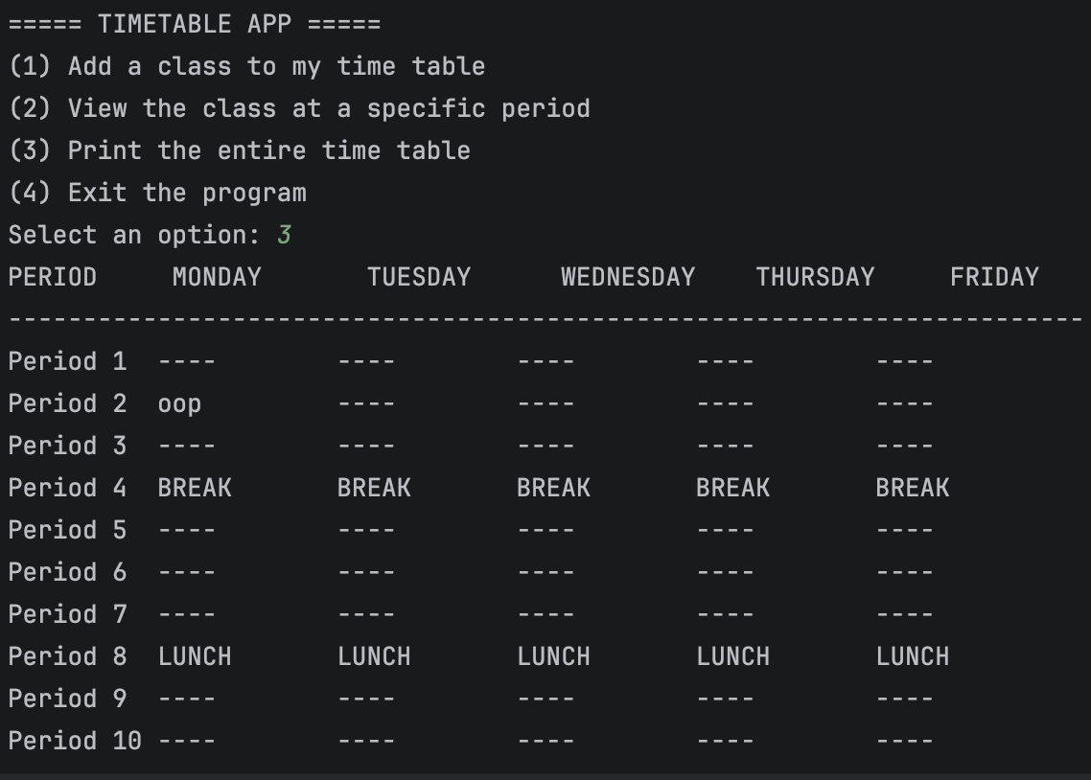
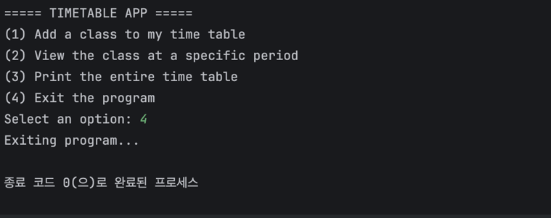

[Catching Error]
